|  |  |  |
| --- | --- | --- |
| Bremer_FinalSelection_Color[1]​​​ | ***​​*Bremer State High School*​*** | |
| **Student name:  Eden Tomes** | **Student number:** |
| **Teacher name:  Mrs. Alexandrou** | |
| **Date handed out: 12/02/2025** | **Date due:** |

|  |  |  |
| --- | --- | --- |
| **Subject** | ​​Mathematics Specialist​ | |
| **Technique** | ​​Problem-solving and modelling task​ | |
| **Unit** | ​​Unit 1: Combinatorics, proof, vectors and matrices​ | |
| **Topic** | ​​Topic 1: Combinatorics​ | |
| **Conditions** | | |
| **Duration** | | 4 weeks (including 3 hours of class time) |
| **Mode/length** | | Written: Up to 10 pages (including tables, figures and diagrams) and a maximum of 2000 words |
| **Individual/group** | | A unique response must be developed by each student |
| **Other** | | Use of technology is required and must go beyond simple computation or word processing |
| **Resources** | | The technology used can include scientific calculator, graphics calculator (CAS or non-CAS), spreadsheet program and/or other mathematical software |

**Mark allocation**

| **Criterion** | **Assessment objectives** | **Marks** |
| --- | --- | --- |
| Formulate | 1, 5 | 4 |
| Solve | 1, 2, 6 | 7 |
| Evaluate | 4, 5 | 5 |
| Communicate | 3, 5 | 4 |
| **Total marks:** | | **20** |

](https://content2.learnon.com.au/secure/ebooks/97813942/9781394269839/images/lightwindow/PSMG11_f02.jpg)**Context**

Football (soccer) is a globally popular sport, with millions following events like the FIFA World Cup and the English Premier League (EPL). Underdog stories, such as Emma Raducanu’s 2021 US Open win or Morocco’s 2022 World Cup journey, captivate audiences worldwide.

Australians, known for supporting underdogs, often question fairness in competitions. For instance, at the 2024 Paris Olympics, Raygun's performance in breaking sparked debate about small teams' success. In leagues like the EPL, with 38 rounds, compared to 26 in the NRL, 27 in the A-League, and 16 in the NFL, does having more rounds reduce weaker teams' chances of winning?

**Task**

In this task, you are going to explore the claim that weaker teams (or players) have a better chance of winning when there are fewer rounds.

You must use mathematical and statistical procedures to determine the validity of the claim. Test your claim using data from a competition or competitions. You may choose to explore the claim from the perspective of the number of rounds in the competition, the number of games required to win a round (for example volleyball, tennis, snooker), or both.

To complete this task, you must:

* present your findings as an investigative report based on the approach to problem-solving and mathematical modelling outlined in the Specialist Mathematics syllabus and on the flow chart on the following page of this instrument
* respond with a range of understanding and skills, such as using mathematical language, appropriate calculations, tables of data, graphs and diagrams
* provide a response that highlights the real-life application of mathematics
* respond using a written report format that can be read and interpreted independently of the instrument task sheet
* develop a unique response
* use both analytic procedures and technology.

**Checkpoints**

* One week after issue date: Students submit evidence of their progress to their teacher.
* Two weeks after issue date: Students submit a draft for feedback. General feedback on drafts is provided to the class, but no individual corrections are made.
* Three weeks after issue date: Students submit evidence of their progress to their teacher.
* Four weeks after issue date: Students submit their final response.

**Authentication strategies**

* You will be provided class time for task completion.
* You will each produce a unique response by using individualised data and producing a unique report.
* You will provide documentation of your progress at indicated checkpoints.
* Your teacher will ensure class cross-marking occurs.
* You will use plagiarism-detection software to submit your response.
* You must acknowledge all sources.
* You must submit a declaration of authenticity.

**Scaffolding**

The approach to problem-solving and mathematical modelling must be used.

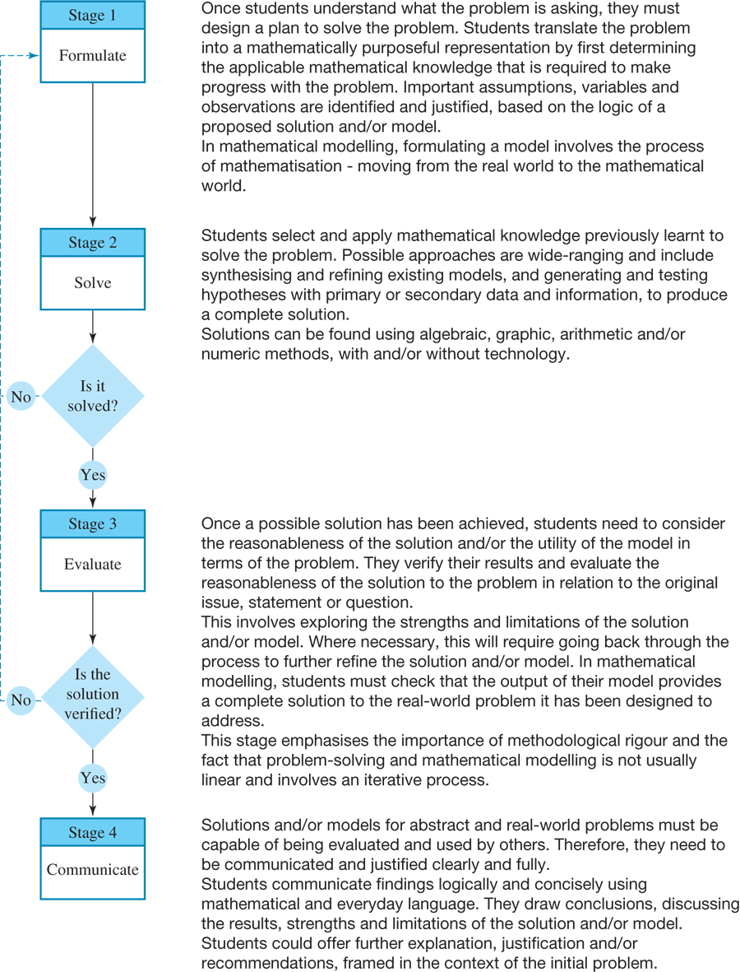

**Instrument-specific marking guide (IA1)**

|  |  |
| --- | --- |
| **Formulate** | **Marks** |
| The student response has the following characteristics: | |
| * justified statements of important assumptions * justified statements of important observations * justified mathematical translation of important aspects of the task | 3–4 |
| * statement of a relevant assumption * statement of a relevant observation * mathematical translation of an aspect of the task. | 1–2 |
| * The student response does not match any of the descriptors above. | 0 |

|  |  |
| --- | --- |
| **Solve** | **Marks** |
| * The student response has the following characteristics: | |
| * accurate use of mathematical knowledge for important aspects of the task * efficient use of technology * a complete solution | 6–7 |
| * use of mathematical knowledge for an important aspect of the task * use of technology * substantial progress towards a solution | 4–5 |
| * simplistic use of mathematical knowledge relevant to the task * simplistic use of technology * progress towards a solution | 2–3 |
| * inappropriate use of mathematical knowledge or technology. | 1 |
| * The student response does not match any of the descriptors above. | 0 |

|  |  |
| --- | --- |
| **Evaluate** | **Marks** |
| The student response has the following characteristics: | |
| * verified results * justified statements about the reasonableness of the solution by considering the assumptions * justified statements about the reasonableness of the solution by considering the observations * justified statements of relevant strengths of the solution * justified statements of relevant limitations of the solution | 4–5 |
| * a verified result * statement about the reasonableness of the solution by considering an assumption or observation * statement of a relevant strength or relevant limitation of the solution | 2–3 |
| * statement about the reasonableness of a result or the solution * statement of a strength or limitation. | 1 |
| * The student response does not match any of the descriptors above. | 0 |

|  |  |
| --- | --- |
| **Communicate** | **Marks** |
| The student response has the following characteristics: | |
| * correct use of appropriate mathematical language * logical organisation of the response, which can be read independently of the task sheet * justification of decisions using mathematical reasoning | 3–4 |
| * use of some appropriate mathematical language * adequate organisation of the response * statement of a relevant decision. | 1–2 |
| * The student response does not match any of the descriptors above. | 0 |